Python Exercises
- Simple Hello World

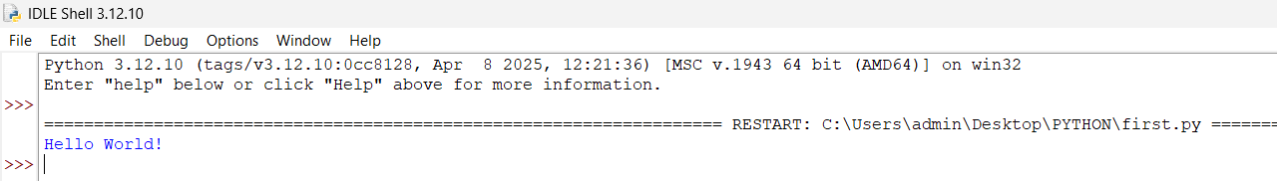

- Jupyter Notebook

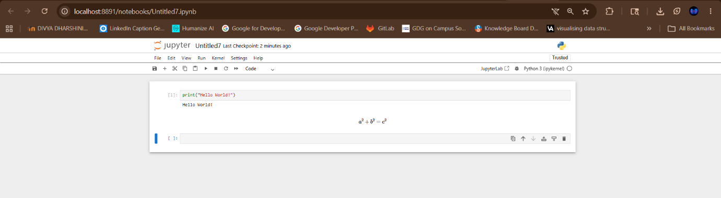

- VS Code Setup

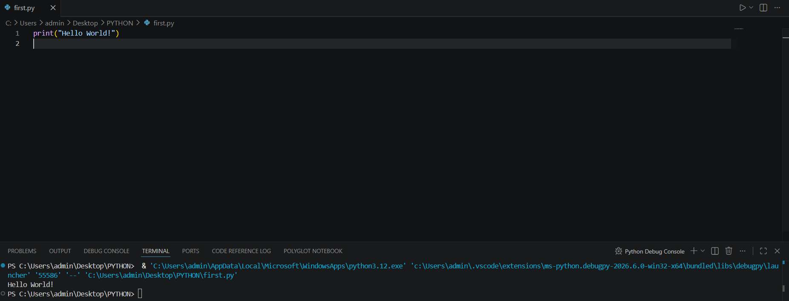

- Float Precision

CODE :
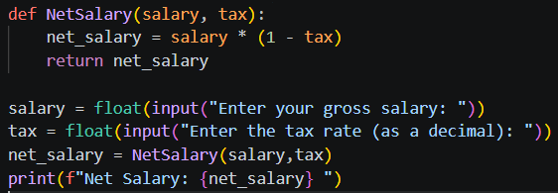
RESULT :
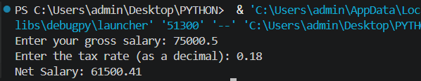

- Multiple Assignment

CODE :

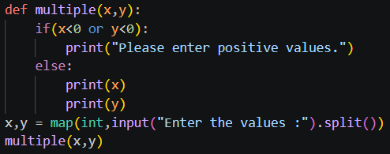

RESULT :

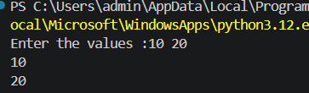

- Modulo Operator
CODE :

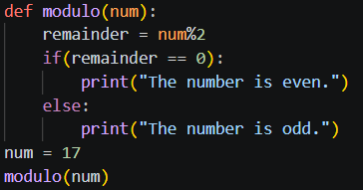

RESULT :

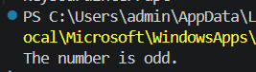

- Floor Division

CODE :

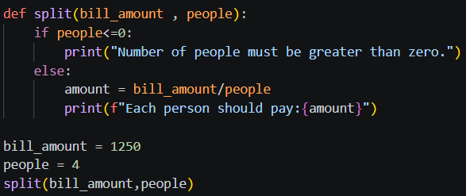

RESULT :

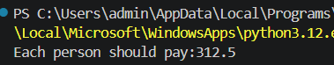

- Min/Max Functions
CODE:
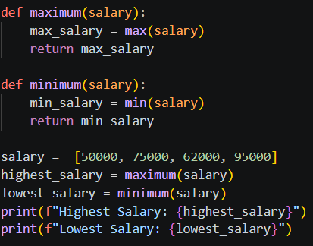

RESULT :

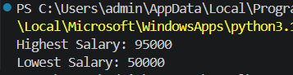

- Basic Input
CODE :
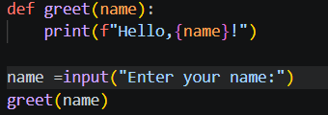

RESULT :
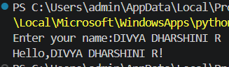

- Numeric Input
CODE :
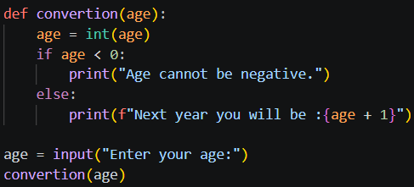
REUSLT :
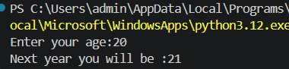

- Float Input
CODE :
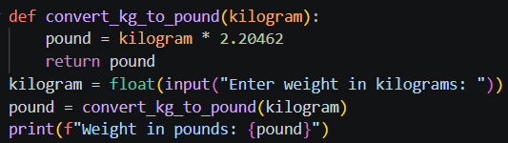
RESULT :
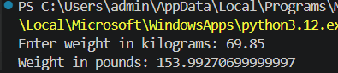

- Simple If
CODE :
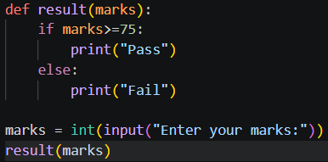
RESULT :
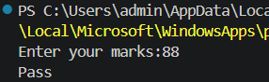

- If-Else
CODE:
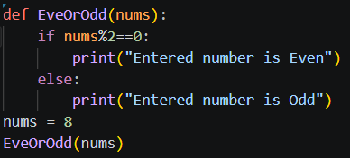
RESULT :
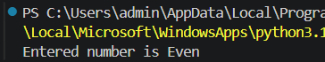

- If-Elif-Else
CODE :
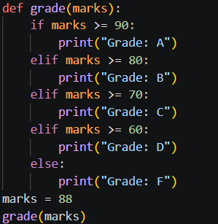
RESULT :
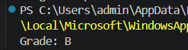
- Nested If
CODE :
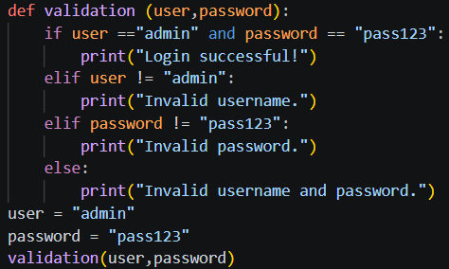
RESULT :
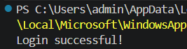

- For Loop Basics
CODE:
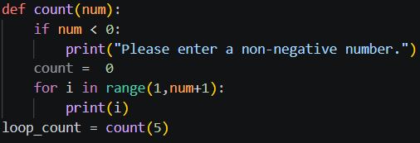
RESULT :
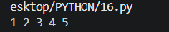
- While Loop
CODE:
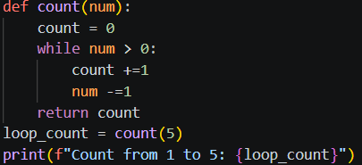
RESULT :
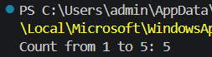
- Break Statement
CODE :
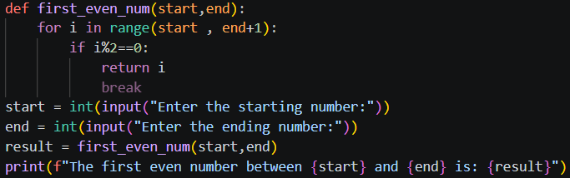
RESULT :
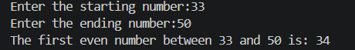
- Continue Statement
CODE:
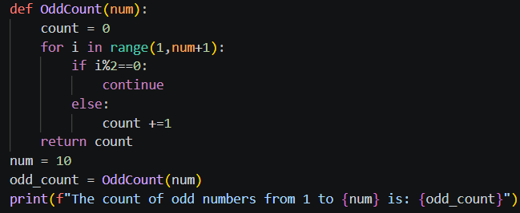
RESULT:
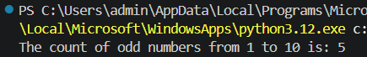
- Pass Statement
CODE:
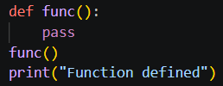
RESULT :
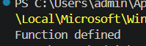
- Consistent Indentation
CODE:
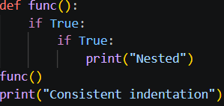
RESULT :
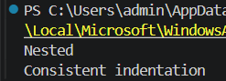
- Comment Usage
CODE :
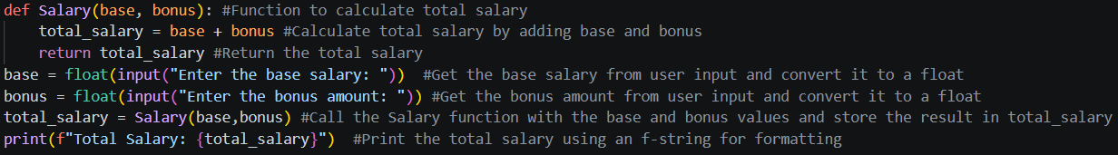
RESULT :
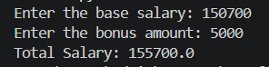
- Import Standard Module
CODE :
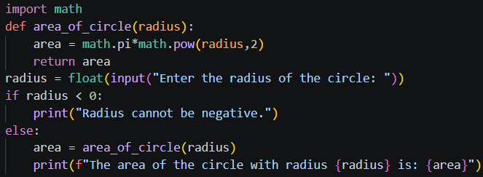
RESULT :
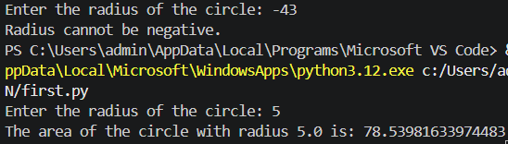
- All Import
CODE :
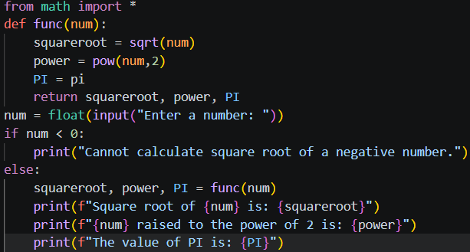
RESULT :
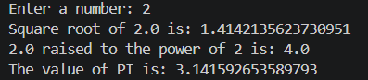
- Parameters
CODE :
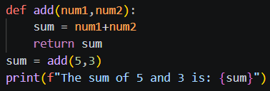
RESULT :
- Multiple Parameters
CODE :
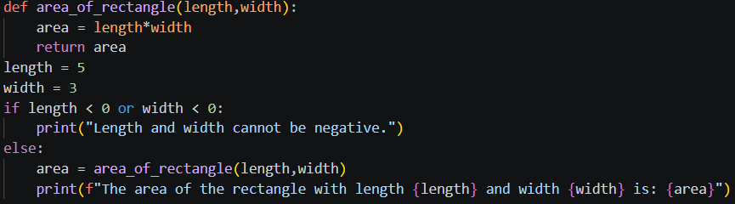
RESULT :
- Len Function
CODE :
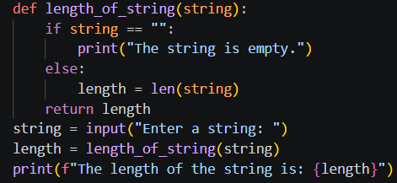
RESULT:
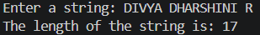

- Write to File
CODE :
def write_file():
with open("greeting.txt", "w") as file:
file.write("Hello World")
print("Message written to file successfully")
write_file()
RESULT :
Message written to file successfully

- Read from File
CODE :
def read_file():
try:
with open("greeting.txt", "r") as file:
content = file.read()
print("File Content:")
print(content)
except FileNotFoundError:
print("File does not exist")
read_file()
RESULT :
File Content:
Hello World

- Basic Try-Except
CODE :
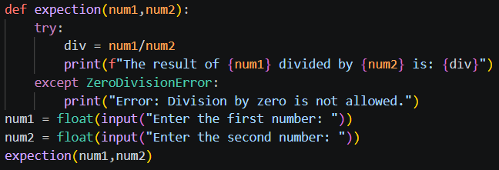
RESULT :
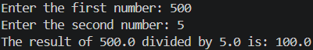
- Create List
CODE :
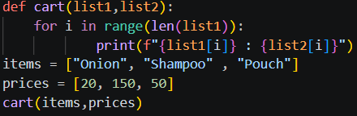
RESULT :
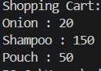
- Append to List
CODE :
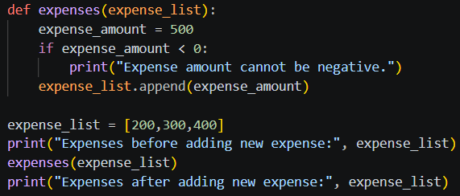
RESULT :
- Update Dictionary
CODE :
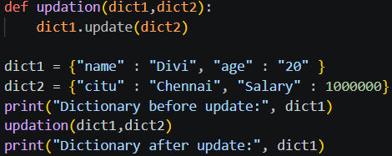
RESULT :

- Nested Dictionary
CODE :
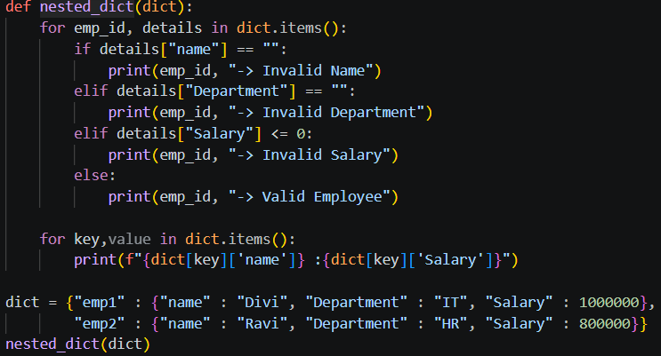
RESULT :
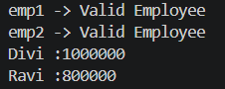

- Create Tuple
CODE :
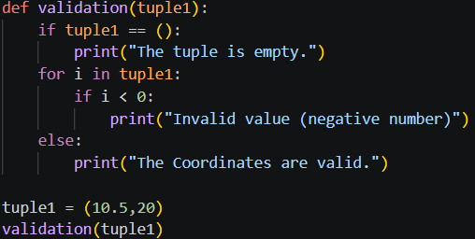
RESULT :
- Set Intersection
CODE :
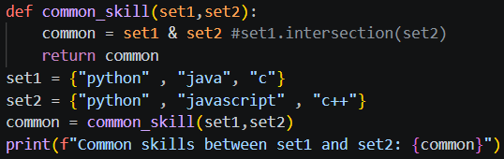
RESULT :
- Multiple Instances
CODE :
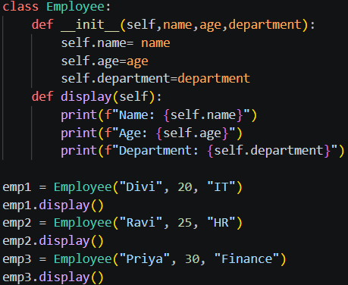

RESULT :
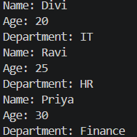

- Method Chaining
CODE :
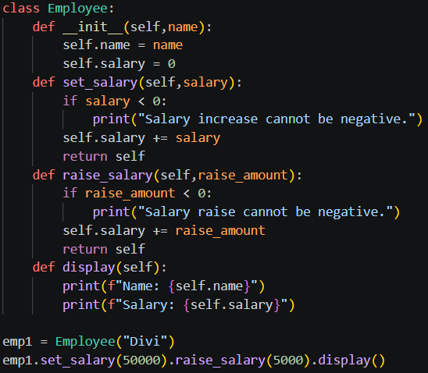
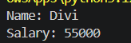
RESULT :

- Polymorphism
CODE :
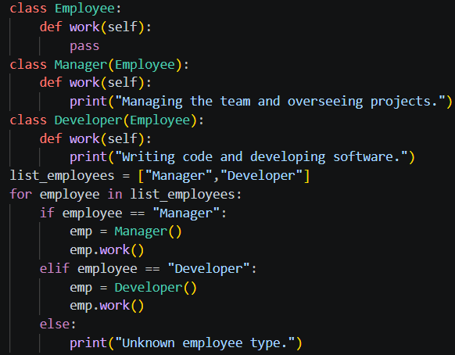
RESULT :
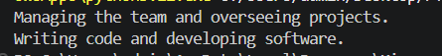
- Class Methods
CODE:
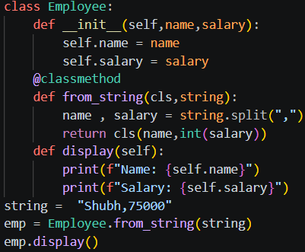
RESULT :


Real-time simulation hands-on questions
- Employee Management System
CODE :
import json
class Employee:
def __init__(self, emp_id, name, department, salary):
self.emp_id = emp_id
self.name = name
self.department = department
self.salary = salary

def __str__(self):
return f"ID: {self.emp_id}, Name: {self.name}, Department: {self.department}, Salary: {self.salary}"

def to_dict(self):
return {
"emp_id": self.emp_id,
"name": self.name,
"department": self.department,
"salary": self.salary
}

employees = {}
employees[101] = Employee(101, "Divya", "AI", 50000)
employees[102] = Employee(102, "Rahul", "HR", 45000)
employees[103] = Employee(103, "Sneha", "Development", 60000)
data = {}
for emp_id, emp in employees.items():
data[emp_id] = emp.to_dict()

with open("emps.json", "w") as file:
json.dump(data, file, indent=4)

print("Employee data saved to emps.json\n")

with open("emps.json", "r") as file:
loaded_data = json.load(file)

loaded_employees = {}

for emp_id, emp_data in loaded_data.items():
loaded_employees[emp_id] = Employee(
emp_data["emp_id"],
emp_data["name"],
emp_data["department"],
emp_data["salary"]
)

print("Employee Details:\n")

for emp in loaded_employees.values():
print(emp)

RESULT :
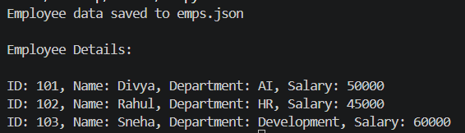
- Data Analysis Pipeline
CODE :
import statistics

sales_data = []

try:
with open("sales.txt", "r") as file:
for line in file:
try:
value = float(line.strip())
sales_data.append(value)

except ValueError:
print(f"Invalid data skipped: {line.strip()}")

if len(sales_data) == 0:
print("No valid sales data found.")

else:
mean_value = statistics.mean(sales_data)
median_value = statistics.median(sales_data)
print("----- Sales Statistics Summary -----")
print(f"Total Records : {len(sales_data)}")
print(f"Sales Data : {sales_data}")
print(f"Mean Sales : {mean_value}")
print(f"Median Sales : {median_value}")

except FileNotFoundError:
print("Error: sales.txt file not found.")

except Exception as e:
print("An unexpected error occurred:", e)

RESULT :
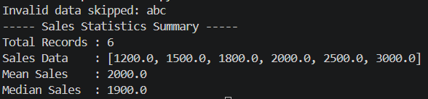

- Configuration Manager
CODE :
import configparser
class Config:
def __init__(self, filename):
self.filename = filename
self.config = configparser.ConfigParser()

def load(self):
self.config.read(self.filename)

class DatabaseConfig(Config):
def validate(self):
required_keys = ["host", "port", "user", "password", "database"]

if "DATABASE" not in self.config:
raise Exception("DATABASE section missing in db.ini")

for key in required_keys:
if key not in self.config["DATABASE"]:
raise Exception(f"Missing required key: {key}")

def display(self):
db = self.config["DATABASE"]

print("----- Database Configuration -----")
print(f"Host : {db['host']}")
print(f"Port : {db['port']}")
print(f"User : {db['user']}")
print(f"Password : {db['password']}")
print(f"Database : {db['database']}")

try:
db_config = DatabaseConfig("db.ini")

db_config.load()
db_config.validate()
db_config.display()

except Exception as e:
print("Error:", e)

RESULT :
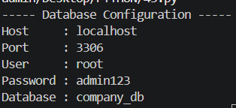

- CSV Data Processor
CODE :
import csv

employees = []

try:
# Read CSV file
with open("employees.csv", "r") as file:
reader = csv.DictReader(file)
employees = [row for row in reader]

for emp in employees:
emp["Salary"] = int(emp["Salary"])

high_salary_employees = [
emp for emp in employees if emp["Salary"] > 50000
]

total_salary = sum(emp["Salary"] for emp in employees)
average_salary = total_salary / len(employees)

print("----- Employee Data -----")
for emp in employees:
print(emp)

print("\n----- Employees with Salary > 50000 -----")
for emp in high_salary_employees:
print(emp)

print(f"\nAverage Salary: {average_salary}")

except FileNotFoundError:
print("Error: employees.csv file not found.")

except Exception as e:
print("Error:", e)

RESULT :
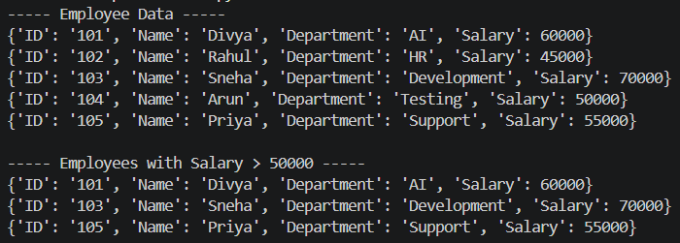

- Expense Tracker
CODE :
import csv
from datetime import datetime

expenses = []

try:
current_month = datetime.now().month
current_year = datetime.now().year
with open("expenses.csv", "r") as file:
reader = csv.DictReader(file)

for row in reader:
expense_date = datetime.strptime(row["date"], "%Y-%m-%d")
if (expense_date.month == current_month and
expense_date.year == current_year):

expenses.append({
"date": row["date"],
"amount": float(row["amount"]),
"category": row["category"]
})

category_totals = {}

for expense in expenses:
category = expense["category"]
amount = expense["amount"]

if category in category_totals:
category_totals[category] += amount
else:
category_totals[category] = amount

print("----- Current Month Expense Summary -----")

for category, total in category_totals.items():
print(f"{category}: ₹{total}")

total_expense = sum(category_totals.values())

print(f"\nTotal Expense: ₹{total_expense}")

except FileNotFoundError:
print("Error: expenses.csv file not found.")

except Exception as e:
print("Error:", e)
RESULT :
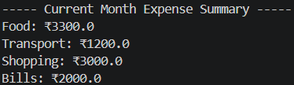
- API Response Handler
CODE :
import requests

class WeatherAPI:
def __init__(self, city):
self.city = city
self.url = f"https://wttr.in/{city}?format=j1"

def get_weather(self):
try:
response = requests.get(self.url, timeout=5)

if response.status_code == 404:
print("Error: City not found.")
return

response.raise_for_status()

data = response.json()

temperature = data["current_condition"][0]["temp_C"]
condition = data["current_condition"][0]["weatherDesc"][0]["value"]

print("----- Weather Report -----")
print(f"City : {self.city}")
print(f"Temperature : {temperature}°C")
print(f"Condition : {condition}")

except requests.exceptions.ConnectionError:
print("Error: Network connection problem.")

except requests.exceptions.Timeout:
print("Error: Request timed out.")

except requests.exceptions.RequestException as e:
print("Error:", e)

except KeyError:
print("Error: Invalid weather data received.")

city_name = input("Enter city name: ")

weather = WeatherAPI(city_name)
weather.get_weather()

RESULT :
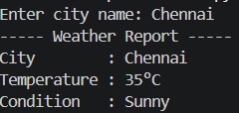
- Complete Calculator Program
CODE :
def calculate(a, b, op):
if op == "+":
return a + b
elif op == "-":
return a - b
elif op == "*":
return a * b
elif op == "/":
return a / b
else:
return "Invalid operator"

try:
num1 = float(input("Enter first number: "))
num2 = float(input("Enter second number: "))
operator = input("Enter operator (+, -, *, /): ")

result = calculate(num1, num2, operator)

print(f"Result: {num1} {operator} {num2} = {result}")

except ValueError:
print("Error: Please enter valid numbers.")

except ZeroDivisionError:
print("Error: Division by zero is not allowed.")

RESULT :
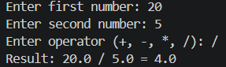

- Shopping Cart System
CODE :
import math

class CartItem:
def __init__(self, name, price, quantity):
self.name = name
self.price = price
self.quantity = quantity

def item_total(self):
return self.price * self.quantity

class ShoppingCart:
def __init__(self):
self.items = []

def add_item(self, item):
self.items.append(item)

def remove_item(self, item_name):
self.items = [
item for item in self.items if item.name != item_name
]

def calculate_total(self):
return sum(item.item_total() for item in self.items)

def print_receipt(self):
print("----- Shopping Receipt -----")

for item in self.items:
print(
f"{item.name} - ₹{item.price} x {item.quantity} = ₹{item.item_total()}"
)

subtotal = self.calculate_total()
gst = subtotal * 0.18
final_total = subtotal + gst

print(f"\nSubtotal : ₹{subtotal}")
print(f"GST (18%): ₹{gst}")
print(f"Final Total : ₹{math.ceil(final_total)}")

cart = ShoppingCart()

cart.add_item(CartItem("Laptop", 50000, 1))
cart.add_item(CartItem("Mouse", 800, 2))
cart.add_item(CartItem("Keyboard", 1500, 1))

cart.remove_item("Mouse")

cart.print_receipt()

RESULT :
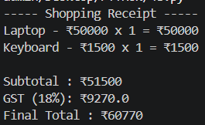

- Temperature Converter GUI
CODE :
from tabulate import tabulate

class Converter:

def celsius_to_fahrenheit(self, c):
return (c * 9/5) + 32

def celsius_to_kelvin(self, c):
return c + 273.15

def fahrenheit_to_celsius(self, f):
return (f - 32) * 5/9

def fahrenheit_to_kelvin(self, f):
return ((f - 32) * 5/9) + 273.15

def kelvin_to_celsius(self, k):
return k - 273.15

def kelvin_to_fahrenheit(self, k):
return ((k - 273.15) * 9/5) + 32

converter = Converter()

print("----- Temperature Converter -----")
print("1. Celsius to Fahrenheit & Kelvin")
print("2. Fahrenheit to Celsius & Kelvin")
print("3. Kelvin to Celsius & Fahrenheit")

choice = int(input("Enter your choice: "))
temp = float(input("Enter temperature value: "))

table = []

if choice == 1:
f = converter.celsius_to_fahrenheit(temp)
k = converter.celsius_to_kelvin(temp)

table = [
["Celsius", f"{temp:.2f} °C"],
["Fahrenheit", f"{f:.2f} °F"],
["Kelvin", f"{k:.2f} K"]
]

elif choice == 2:
c = converter.fahrenheit_to_celsius(temp)
k = converter.fahrenheit_to_kelvin(temp)

table = [
["Fahrenheit", f"{temp:.2f} °F"],
["Celsius", f"{c:.2f} °C"],
["Kelvin", f"{k:.2f} K"]
]

elif choice == 3:
c = converter.kelvin_to_celsius(temp)
f = converter.kelvin_to_fahrenheit(temp)

table = [
["Kelvin", f"{temp:.2f} K"],
["Celsius", f"{c:.2f} °C"],
["Fahrenheit", f"{f:.2f} °F"]
]

else:
print("Invalid choice")

if table:
print("\nConversion Result:")
print(tabulate(table, headers=["Scale", "Value"], tablefmt="grid"))

RESULT :
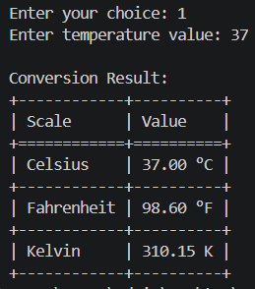

- Backup Utility
CODE :
import os
import shutil

source_folder = "source_files"
backup_folder = "backup_files"

copied_files = set()

os.makedirs(backup_folder, exist_ok=True)

try:
files = os.listdir(source_folder)

with open("backup.log", "a") as log_file:

for file_name in files:

source_path = os.path.join(source_folder, file_name)
backup_path = os.path.join(backup_folder, file_name)

if file_name in copied_files:
log_file.write(f"Skipped duplicate: {file_name}\n")
continue

try:
shutil.copy(source_path, backup_path)

copied_files.add(file_name)

log_file.write(f"Copied: {file_name}\n")

except FileNotFoundError:
log_file.write(f"File not found: {file_name}\n")

except PermissionError:
log_file.write(f"Permission denied: {file_name}\n")

print("Backup completed successfully.")

except FileNotFoundError:
print("Error: Source folder not found.")

except Exception as e:
print("Error:", e)

RESULT :

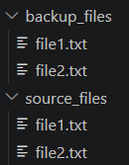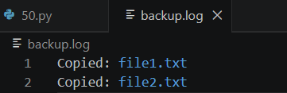

- URL Shortener
CODE :
import hashlib

class URLShortener:

def __init__(self):
self.url_database = {}

def shorten_url(self, original_url):

short_code = hashlib.md5(
original_url.encode()
).hexdigest()[:6]

self.url_database[short_code] = original_url

return short_code

def retrieve_url(self, short_code):

if short_code in self.url_database:
return self.url_database[short_code]

return "URL not found"

shortener = URLShortener()

url1 = "https://www.google.com"
url2 = "https://www.python.org"

short1 = shortener.shorten_url(url1)
short2 = shortener.shorten_url(url2)

print("----- Shortened URLs -----")
print(f"{url1} -> {short1}")
print(f"{url2} -> {short2}")

print("\n----- Redirect Simulation -----")

print(f"{short1} redirects to:")
print(shortener.retrieve_url(short1))

print(f"\n{short2} redirects to:")
print(shortener.retrieve_url(short2))

RESULT :
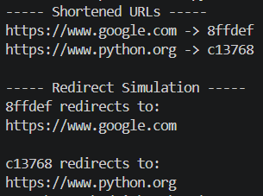

- Gradebook System
CODE :
import json

students = {}

def add_grade(student, grade):

if 0 <= grade <= 100:

if student not in students:
students[student] = []

students[student].append(grade)

else:
print("Invalid grade. Grade must be between 0 and 100.")

def calculate_gpa(student):

if student in students and len(students[student]) > 0:
return sum(students[student]) / len(students[student])

return 0

def save_data():

with open("grades.json", "w") as file:
json.dump(students, file, indent=4)

def load_data():

global students

try:
with open("grades.json", "r") as file:
students = json.load(file)

except FileNotFoundError:
print("No saved data found.")

def class_average():

all_grades = []

for grades in students.values():
all_grades.extend(grades)

if len(all_grades) > 0:
return sum(all_grades) / len(all_grades)

return 0

add_grade("Divya", 95)
add_grade("Rahul", 80)
add_grade("Divya", 88)
add_grade("Sneha", 91)
add_grade("Rahul", 76)
add_grade("Arun", 105)

save_data()

load_data()

print("----- Student GPA -----")

for student in students:
print(f"{student}: {calculate_gpa(student):.2f}")

print(f"\nClass Average: {class_average():.2f}")

RESULT :
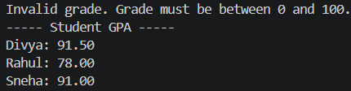

- Task Scheduler
CODE :
from datetime import datetime

class Task:

def __init__(self, name, due_date, priority):
self.name = name
self.due_date = datetime.strptime(due_date, "%Y-%m-%d")
self.priority = priority

def __str__(self):
return (
f"Task: {self.name} | "
f"Due: {self.due_date.strftime('%Y-%m-%d')} | "
f"Priority: {self.priority}"
)

tasks = []

tasks.append(Task("Complete Assignment", "2026-06-10", "High"))
tasks.append(Task("Pay Electricity Bill", "2026-06-02", "Medium"))
tasks.append(Task("Project Submission", "2026-06-15", "High"))
tasks.append(Task("Buy Groceries", "2026-06-05", "Low"))

tasks.sort(key=lambda task: task.due_date)

today = datetime.now()

overdue_tasks = [
task for task in tasks if task.due_date < today
]

print("----- Task Schedule -----")

for task in tasks:
print(task)

print("\n----- Overdue Tasks -----")

if overdue_tasks:
for task in overdue_tasks:
print(task)
else:
print("No overdue tasks")

RESULT :
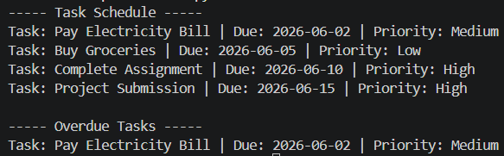

- Inventory Manager
CODE :
class Product:

def __init__(self, name, price):
self.name = name
self.price = price

def display(self):
return f"{self.name} - ₹{self.price}"

class Perishable(Product):

def __init__(self, name, price, expiry_date):
super().__init__(name, price)
self.expiry_date = expiry_date

def display(self):
return (
f"{self.name} - ₹{self.price} "
f"(Expiry: {self.expiry_date})"
)

class Electronics(Product):

def __init__(self, name, price, warranty):
super().__init__(name, price)
self.warranty = warranty

def display(self):
return (
f"{self.name} - ₹{self.price} "
f"(Warranty: {self.warranty})"
)

inventory = {}

inventory["Milk"] = {
"product": Perishable("Milk", 50, "2026-06-10"),
"stock": 5
}

inventory["Bread"] = {
"product": Perishable("Bread", 40, "2026-06-07"),
"stock": 2
}

inventory["Laptop"] = {
"product": Electronics("Laptop", 60000, "2 Years"),
"stock": 10
}

inventory["Mobile"] = {
"product": Electronics("Mobile", 25000, "1 Year"),
"stock": 3
}

low_stock_alerts = set()

for item, details in inventory.items():

if details["stock"] < 5:
low_stock_alerts.add(item)

print("----- Inventory Summary -----")

for item, details in inventory.items():

print(
f"{details['product'].display()} | "
f"Stock: {details['stock']}"
)

print("\n----- Low Stock Alerts -----")

for item in low_stock_alerts:
print(item)

RESULT :
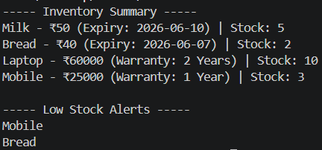
- Budget Planner
CODE :
import matplotlib.pyplot as plt

class Category:

def __init__(self, name, limit):
self.name = name
self.limit = limit
self.spent = 0

def add_expense(self, amount):
self.spent += amount

def check_budget(self):

if self.spent > self.limit:
print(f"Alert: {self.name} exceeded the budget!")

def remaining(self):
return self.limit - self.spent

categories = {}

num = int(input("Enter number of categories: "))

for i in range(num):

name = input("Enter category name: ")
limit = float(input(f"Enter budget limit for {name}: "))

categories[name] = Category(name, limit)

while True:

print("\n1. Add Expense")
print("2. View Summary")
print("3. Exit")

choice = input("Enter choice: ")

if choice == "1":

category_name = input("Enter category: ")

if category_name in categories:

amount = float(input("Enter expense amount: "))

categories[category_name].add_expense(amount)

categories[category_name].check_budget()

else:
print("Category not found")

elif choice == "2":

print("\n----- Budget Summary -----")

for category in categories.values():

print(
f"{category.name} | "
f"Limit: ₹{category.limit} | "
f"Spent: ₹{category.spent} | "
f"Remaining: ₹{category.remaining()}"
)

elif choice == "3":
break

else:
print("Invalid choice")

labels = [category.name for category in categories.values()]
amounts = [category.spent for category in categories.values()]

plt.pie(amounts, labels=labels, autopct="%1.1f%%")
plt.title("Monthly Budget Spending")
plt.show()

RESULT :
